Explain the following questions in two simple sentences

1. What is the use of the git add command?

**Add files to the staging area**

1. Write the command to create a branch “feature-login”

**git checkout -b feature-login**

1. What is a pull request? Write the steps involved in creating a pull request.

**Request for your changes to be reviewed before being merged into the main branch.**

**First, push the changes in your branch to remote. Then go to the repo and open a pull request.**

1. How do you add collaborators?

**Go to Settings in your repo. There will be a Collaborators tab. You can add from there.**

1. What is the command used to commit our changes in github repo?

**git commit -m “msg”**

1. Create a github account and repository to save all your assignment tasks. Example repository name: rg-assignments
2. Create a branch called feature-java(you can use it later to push all your java related tasks to this branch)
3. Install IntelliJ IDE. Create a simple java project displaying “Hello World!!”and share the screenshot.

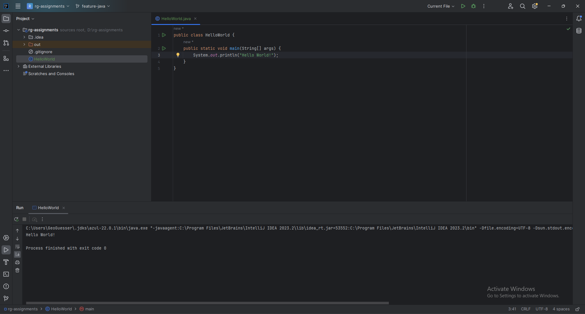

1. In IntelliJ IDE, explore the shortcut keys for the following
   1. To run the project

Shift + F10

* 1. To select a line

Ctrl + w

* 1. To comment/uncomment a line

Ctrl + /

* 1. To delete a line

Ctrl + Shift + k (custom) or Ctrl + x